|  |  |
| --- | --- |
| Document Name: | **Excalibur Launcher- SRS** |
|  | **S**oftware **R**equirements **S**pecification |
| Document File Path in StarTeam: | D:\ExcaliburLauncher\documentation |
| Revision: | **A** |

Revision History Control

|  |  |  |  |  |
| --- | --- | --- | --- | --- |
| Rev. | Description (changes, additions) | Author | Approved by | Issue Date |
| A | Initial version | Shia |  | 18/2/17 |
|  |  |  |  |  |
|  |  |  |  |  |
|  |  |  |  |  |
|  |  |  |  |  |
|  |  |  |  |  |
|  |  |  |  |  |
|  |  |  |  |  |

**Table of Contents**

1. Introduction 3

1.1 Scope 3

1.2 Acronyms and Definitions 3

1.3 References 3

2. Overall Description 4

2.1 Product Perspective 4

2.2 Product Architecture 5

2.3 Software Functions 5

3. Functional Requirements 5

3.1 [Find Excalibur Devices] 5

4. Interface Requirements 7

4.1 User Interface and GUI 7

4.2 Hardware Interfaces 7

4.3 Software Interfaces 7

5. Risks 8

5.1 [Name_1 Risk] 8

6. T.B.D Follow-up 9

Appendix A: Detailed Diagrams 9

# Introduction

## Scope

The ***Excalibur Launcher*** shell will provide a single source for running and monitoring the status of installed Excalibur devices and software.

***Excalibur Launcher*** The Excalibur hardware and the software tools available for these products.

## Acronyms and Definitions

|  |  |
| --- | --- |
| EL | Excalibur Launcher |
|  |  |

## References

|  |  |  |
| --- | --- | --- |
|  | Document Title | Revision |
|  |  |  |

# Overall Description

## Product Perspective



## Product Architecture



## Software Functions

Detect any Excalibur devices on PC by reading the registry

Check found devices or installed and working

Display devices found and status

# Functional Requirements

**Excalibur Launcher Use Case Diagram**

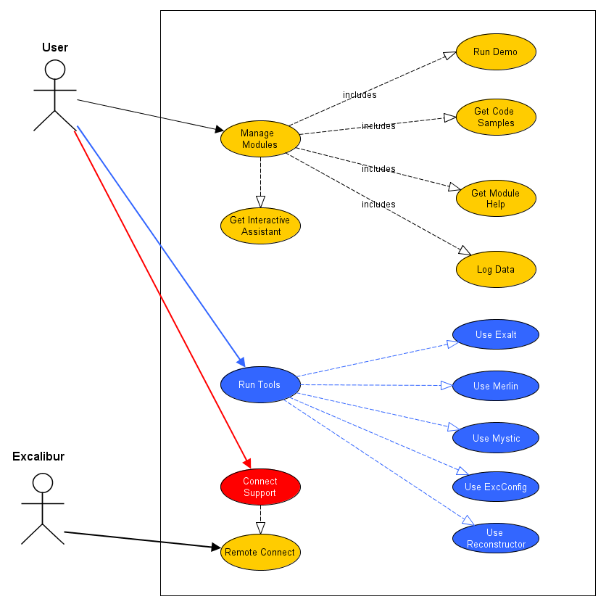

## Find Excalibur Devices

* **Goal**

**Search PC to find Excalibur devices and modules and display in Launcher**

* **Description**

**On running**

When first run the ***Excalibur Launcher*** will search the PC for installed

Excalibur devices and modules. Check they are installed and pass initialization. The status of each device/module found will be displayed on the main window of the ***Excalibur Launcher.***

* **Actors**

User, PC with installed Excalibur devices and ***Excalibur Launcher*** software

* **Pre-conditions**

***Excalibur Launcher*** started

* **Post-conditions**

***Excalibur Launcher*** displays Devices, modules and status

* **Processing**

**Basic Flow**

1. *The case begins when the User starts* ***Excalibur Launcher***
2. Onstartup ***Excalibur Launcher*** automatically*searches for Excalibur devices* and modules similar to Exalt.
3. ***Excalibur Launcher*** checks the found devices/modules
4. *Use case ends when* ***Excalibur Launcher*** displays status of devices/modules

# Interface Requirements

## User Interface and GUI

**TO DO**

## Hardware Interfaces

Use Software tools and drivers to establish connection between installed devices/modules and ***Excalibur Launcher.***

## Software Interfaces

Call Excalibur 4000 card dll to obtain information about installed devices and moudules.

# Risks

n/a – no risks as this stage

## [Name_1 Risk]

Replace the “NAME_1” string with the actual Risk name in the sub section title.

**Description:** Describe the risk.

**Probability:** Rank the probability that the risk will occur. Choose a number from 1 to 5, when rank 5 is the greatest probability that it will occur

**Severity:** Rank the severity of the risk in terms of impact on the project if the risk occurs. Choose a number from 1 to 5.

**Mitigation:**

# T.B.D Follow-up

Review back the entire document from the beginning. If there are any TBDs add them to the following TBD follow-up table, and specify who is responsible to resolve the TBD and when.

|  |  |  |
| --- | --- | --- |
| **TBD** | **Responsibility** | **Due Date** |
| The name of the section with a TBD and the issue that is TBD | Who is responsible to resolve the TBD | The Date, or a phase or stage in the development life cycle, when the TBD will be resolved |
|  |  |  |
|  |  |  |

Appendix A: Detailed Diagrams

If diagrams produced by a design tool (e.g. Enterprise Architect) are available then insert them here and add brief explanations when necessary. These diagrams may include Activity and Sequence diagrams of a use case and class diagrams.